**CS-114 - Fundamental of Programing**

Lab Manual # 05

Lab Tasks

**Course Instructor:** Khawaja Fahad Iqbal

**Lab Instructor:** Muhammad Affan

**Student Name:** Muhammad Talha Kashif

**CMS ID:** 454135

#include<iostream>

**LAB TASK 1**

using namespace std;

int main() {

int x=1;

do

{

cout<<"enter a number: ";

cin>>x;

}

while(x>0);

return 0;

}

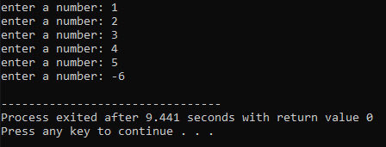

#include<iostream>

#include<math.h>

using namespace std;

**LAB TASK 2**

cout<<"Enter m for multiplication"<<endl;

int num1,num2,result;

char function,repeat;

cout<<"Enter a for addition"<<endl;

cout<<"Enter s for subtraction"<<endl;

cout<<"Enter d for division"<<endl;

cout<<"Enter o for modulus"<<endl;

cout<<"Enter p for using power"<<endl;

cout<<"[ONLY ENTER IN LOWERCASE WHEN CHOOSING THE FUNCTION]"<<endl;

repeat='y';

do

{

cout<<"Enter first number: ";

cin>>num1;

cout<<"Enter second number: ";

cin>>num2;

cout<<"Select function: ";

cin>>function;

switch(function)

{

case 'a':

result=num1+num2;

cout<<"Answer is: "<<result<<endl;

cout<<" "<<endl;

break;

case 's':

result=num1-num2;

cout<<"Answer is: "<<result<<endl;

**LAB TASK 2**

cout<<" "<<endl;

break;

case 'm':

result=num1*num2;

cout<<"Answer is: "<<result<<endl;

cout<<" "<<endl;

break;

case 'd':

result=num1/num2;

cout<<"Answer is: "<<result<<endl;

cout<<" "<<endl;

break;

case 'o':

result=num1%num2;

cout<<"Answer is: "<<result<<endl;

cout<<" "<<endl;

break;

case 'p':

result=pow(num1,num2);

cout<<"Would you like to proceed? Enter choice ---> ";

cin>>repeat;

}

while(repeat=='y'||repeat=='Y');

return 0;

}

cout<<”Answer is: "<<result<<endl;

cout<<" "<<endl;

break;

default:

cout<<"No valid function chosen";

}

cout<<"Enter 'y' if you wish to proceed with further calculations"<<endl;

cout<<"Enter any other character if you are finished with your calculations"<<endl;

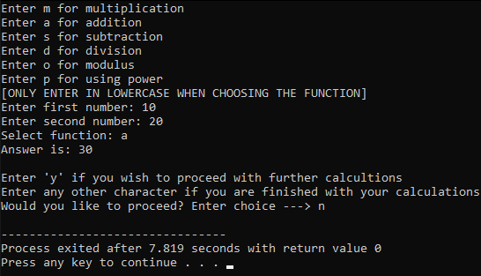 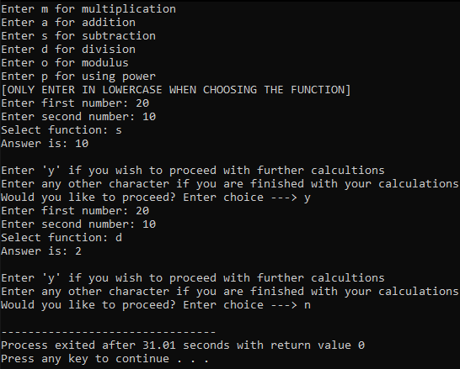 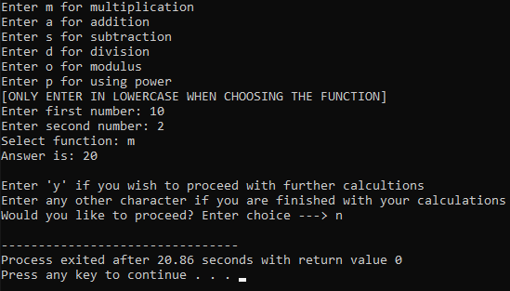 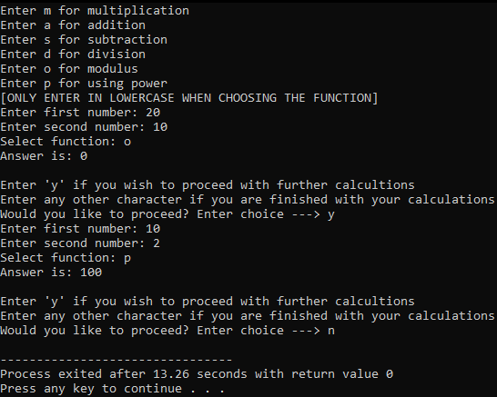

**LAB TASK 2**

**LAB TASK 2**

#include<iostream>

using namespace std;

int i,start,end,sum,result;

cout<<"Enter starting number: ";

**LAB TASK 3a**

cin>>start;

cout<<"Enter ending number: ";

cin>>end;

sum=0;

i=start;

while(i>=start&&i<=end)

{

result=i%2;

if(result==0)

{

sum=sum+i;

}

i++;

}

cout<<"The sum of all even numbers between "<<start<<" and "<<end<<" (inclusive) is: "<<sum;

return 0;

}

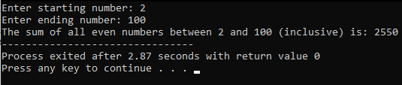

#include<iostream>

#include<math.h>

**LAB TASK 3b**

using namespace std;

int i,sum,start,end;

double result;

cout<<"Enter starting number: ";

cin>>start;

cout<<"Enter ending number: ";

cin>>end;

sum=0;

result=0;

i=start;

while(i>=start&&i<=end)

{

result=sqrt(i);

if(result==floor(result))

{

sum=sum+i;

}

i++;

}

cout<<"The sum of all squares between "<<start<<" and "<<end<<" (inclusive) is: "<<sum;

return 0;

}

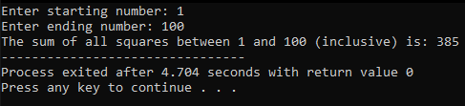

#include<iostream>

#include<math.h>

using namespace std;

**LAB TASK 4a**

double base,StartPower,EndPower,result=0.00,i=0.00;

cout<<"Enter base number: ";

cin>>base;

cout<<"Enter starting power: ";

cin>>StartPower;

i=StartPower;

cout<<"Enter ending power: ";

cin>>EndPower;

while(i>=StartPower && i<=EndPower)

{

result=pow(base,i);

cout<<base<<"^"<<i<<" = "<<result<<endl;

++i;

}

return 0;

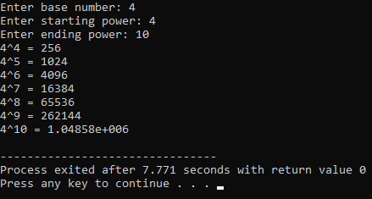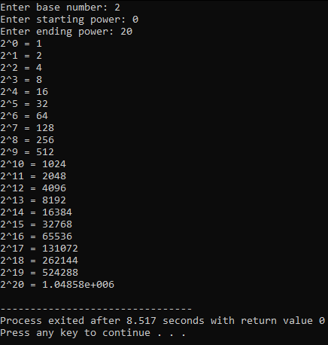}

#include<iostream>

using namespace std;

**LAB TASK 4b**

int i,start,end,sum,result;

cout<<"Enter starting number: ";

cin>>start;

cout<<"Enter ending number: ";

cin>>end;

sum=0;

i=start;

while(i>=start&&i<=end)

{

result=i%2;

if(result==1)

{

sum=sum+i;

}

i++;

}

cout<<"The sum of all odd numbers between "<<start<<" and "<<end<<" (inclusive) is: "<<sum;

return 0;

}

